**Institute of Engineering & Technology**

**Devi Ahilya Vishwavidyalaya, Indore (M.P)**

**Department of Computer Science & Engineering**



**DATABASE MANAGEMENT SYSTEM(CER4C4)**

**Lab Assignment-1**

**Submitted To: Submitted By:**

**Mrs. Jyoti Haveliya Mam Tanishq Chauhan (21C4184)**

**CS-Dept CS “B” 2nd Year**

**IET-DAVV**

**Lab Assignment-1**

1. **Create the SALECOMP database.**

**Query:-** CREATE DATABASE SALECOMP;

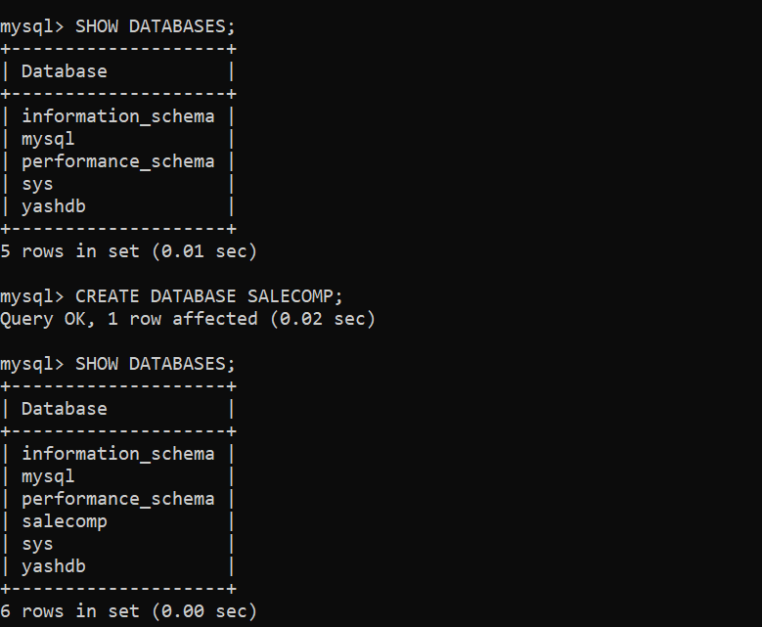

1. **Create an EMPLOYEE table within SALECOMP database having following structure:**

**Query:-** CREATE TABLE EMPLOYEE

* (
* Emp_num int NOT NULL,
* First_Name varchar(15) NOT NULL,
* Last_Name varchar(20),
* DOB Date,
* Salary Decimal(10,4),
* PRIMARY KEY(Emp_num)
* );

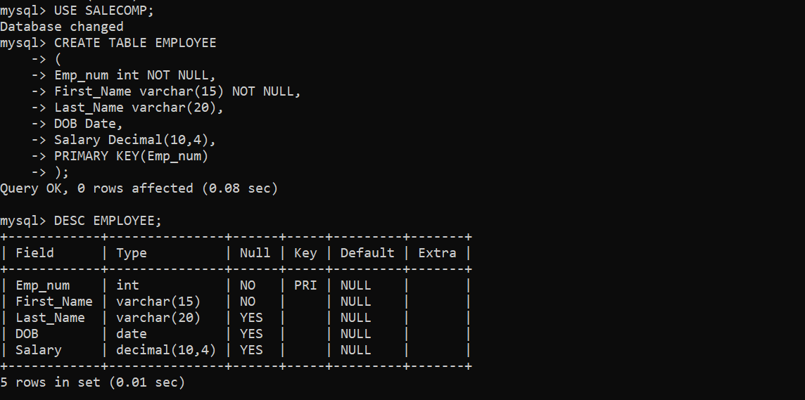

1. **Populate the table with following records:**

**Query:-** INSERT INTO EMPLOYEE

* (Emp_num, First_Name, Last_Name, DOB, Salary)
* VALUES (101, ‘Smith’ ‘Futterkiste’, ‘1980-12-17’, 12500.60),
* (102, ‘Allen’, NULL, ‘1982-05-12’, 13000.80);

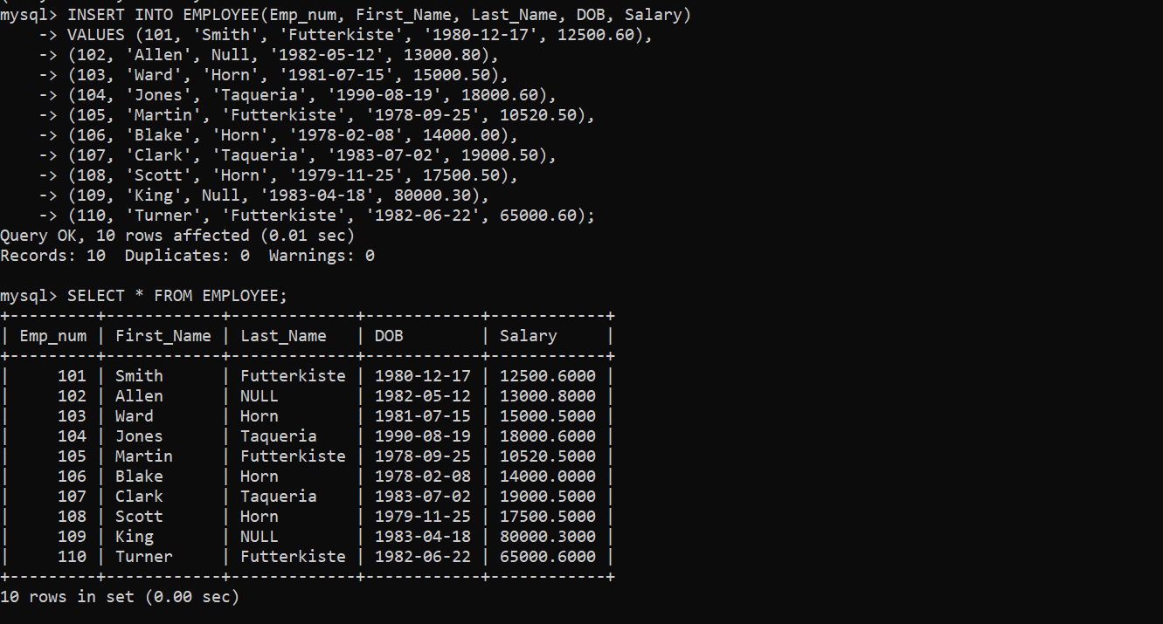

1. **WAQ to change the field name First_name with F_Name and Last_name with L_name.**

**Query:-** ALTER TABLE EMPLOYEE

* CHANGE First_Name F_Name varchar(15) NOT NULL,
* CHANGE Last_name L_name varchar(20);

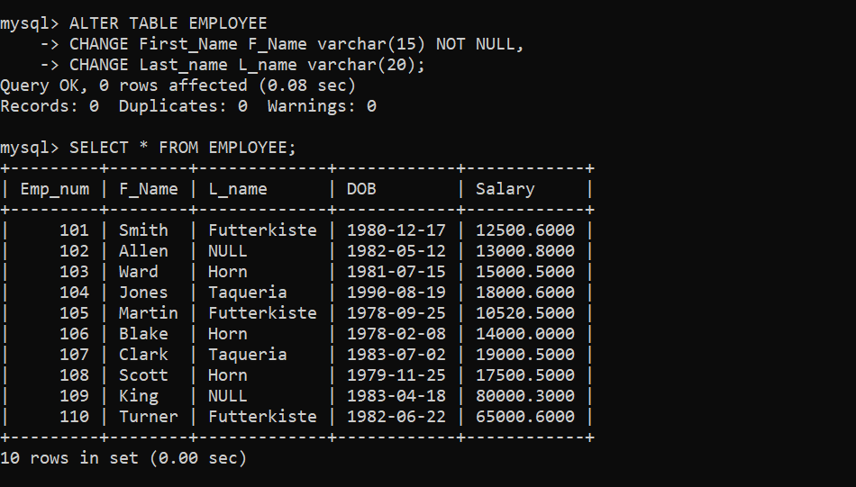

1. **WAQ to add a column Phone_No before DoB column.**

**Query:-** ALTER TABLE EMPLOYEE

* ADD COLUMN Phone_No int AFTER L_name;

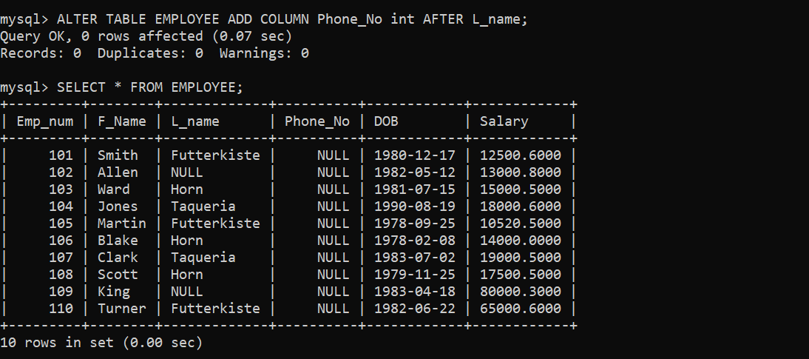

1. **WAQ to add a column Emp_id in the beginning of the table.**

**Query:-** ALTER TABLE EMPLOYEE

* ADD COLUMN Emp_id int FIRST;

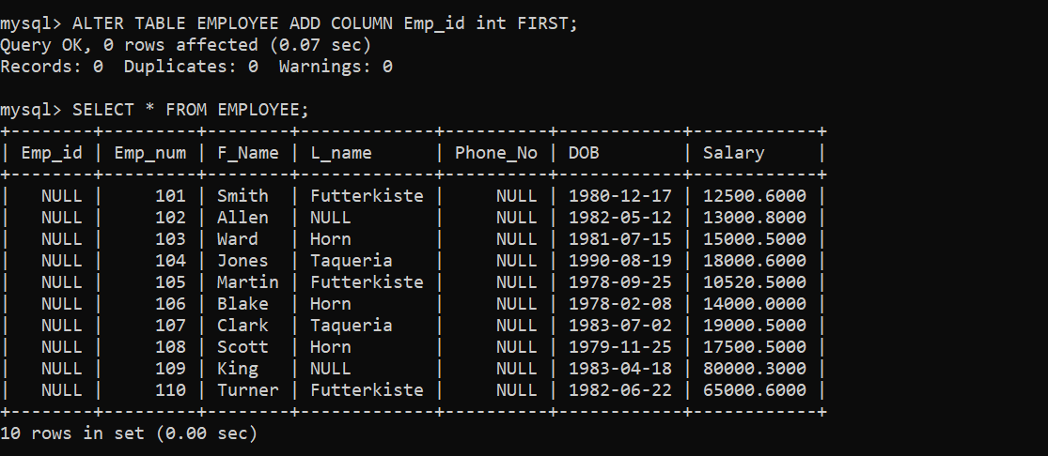

1. **WAQ to drop the Emp_id and Phone_No from the table.**

**Query:-** ALTER TABLE EMPLOYEE

* DROP COLUMN Emp_id,
* DROP COLUMN Phone_No;

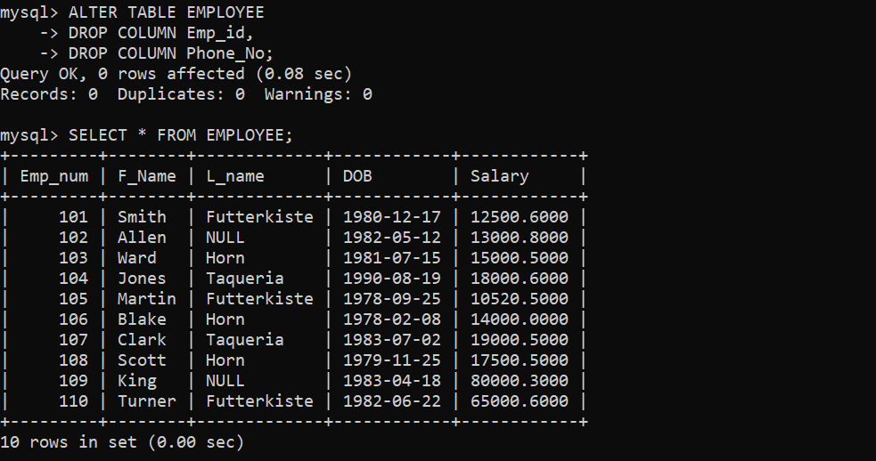

1. **WAQ to display the complete table.**

**Query:-** SELECT * FROM EMPLOYEE;

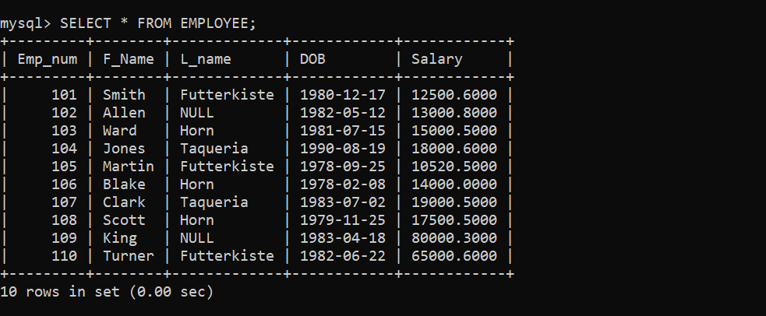

1. **WAQ to display only Employee number, First_Name and Last_name from the table.**

**Query:-** SELECT Emp_num, F_Name, L_name FROM EMPLOYEE;

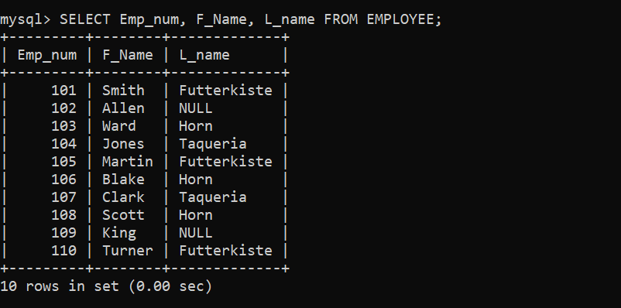

1. **WAQ to find the record of all employees whom birth before 1980s.**

**Query:-** SELECT * FROM EMPLOYEE

* WHERE YEAR(DOB) <= 1980;

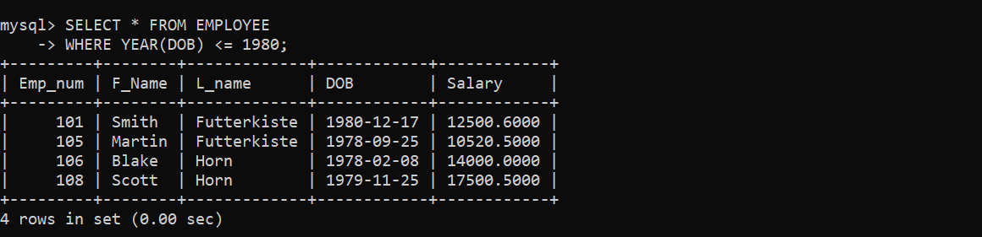

1. **WAQ to find the record of those employees whose employee id is 104 and 108.**

**Query:-** SELECT * FROM EMPLOYEE

* WHERE Emp_num = 104 OR Emp_num = 108;

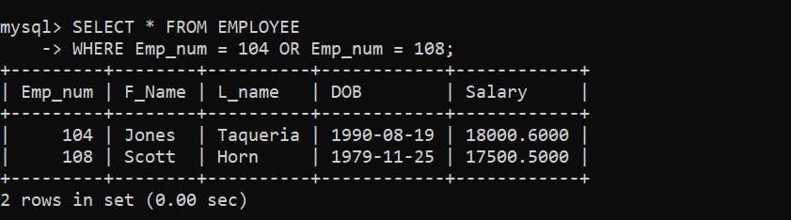

1. **WAQ to set the last name as Hardy wherever the last name is null in the table.**

**Query:-** UPDATE EMPLOYEE

* SET L_name = ‘Hardy’
* WHERE L_name = ‘NULL’;

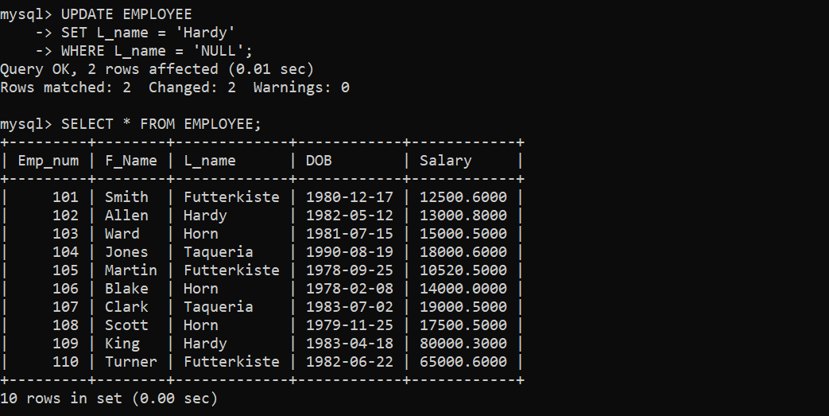

1. **WAQ to delete the record of employees whose salary is less than 12000.00.**

**Query:-** DELETE FROM EMPLOYEE

* WHERE Salary < 12000.00;

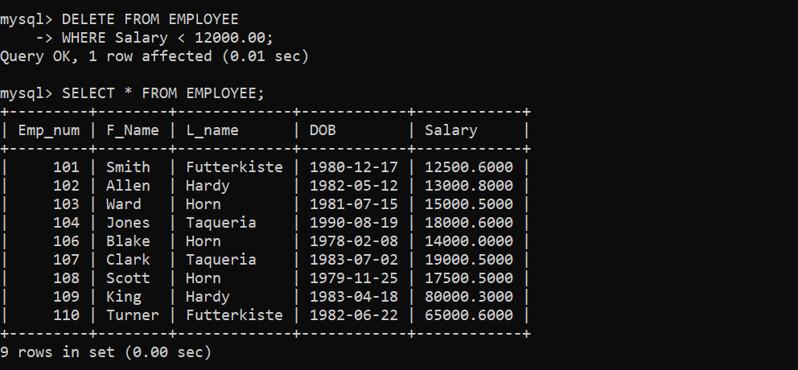

1. **WAQ to display the record of those employees whose birth year is between 1978 to 1980.**

**Query:-** SELECT * FROM EMPLOYEE

* WHERE YEAR(DOB) BETWEEN 1978 AND 1980;

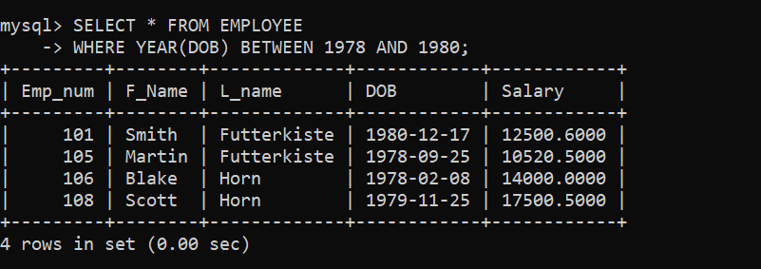

1. **WAQ to display Employee number and first name of employee whose employee number is not 104 and 108.**

**Query:-** SELECT Emp_num, F_Name FROM EMPLOYEE

* WHERE Emp_num NOT IN (104, 108);

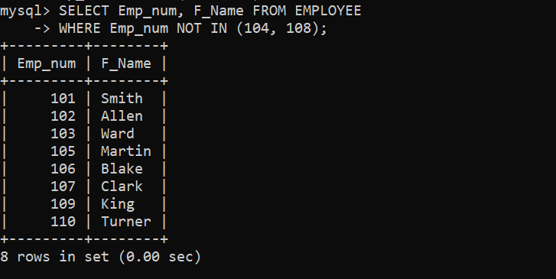

1. **WAQ to assign a new name to the Employee table.**

**Query:-**RENAME TABLE EMPLOYEE TO EMPLOYEE_DETAILS;

